14.72: a) The average density of a filled barrel is 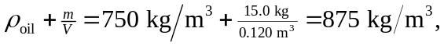which is less than the density of seawater, so the barrel floats.
b) The fraction that floats (see Problem 14.23) is

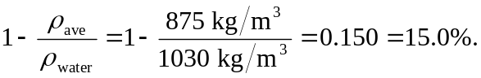

c) The average density is 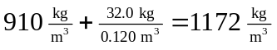 which means the barrel sinks. In order to lift it, a tension is required.

